CHAPTER II

The Transatlantic Cable

Introduction

We take it for granted that we can communicate across the globe, instantaneously. Even just a few decades ago, in the 1960s, it was perfectly possible to pick up the phone and be connected to friends and family anywhere in the world. But in the 1800s high-speed communication was by nothing more than hand-written letters delivered by ship.

What an amazing idea, then, to lay a cable across the Atlantic Ocean (fig. 1) to enable messages to be conveyed in minutes, or even seconds. The sheer scale of the operation – laying 3000 km of cable from ships in rough seas making sure that all the connections were properly made – is something that even today we find challenging. Yet we forget that even at home we grumble when we have trouble with dodgy cables to our TV antenna or we regret buying cheap network cables for the computer.

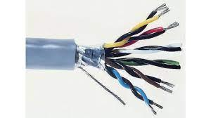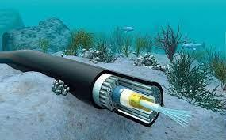

Fig. 1. A sub-ocean cable.

Think, then, to 1858 when the same issues were explored but on a vast scale. The resistance, capacitance and inductance of a long cable were not fully understood and great minds were set to work. Names you may have heard of – Maxwell, Kelvin, Brunel and even Prince Albert – all played their part. But the real unsung hero was Oliver Heaviside.

There are many non-technical accounts of the laying of the transatlantic cable, which is one of the greatest achievements of nineteenth century science, engineering and finance [see e.g. ref. (1)]. However technical details tend to be buried in more obscure publications. There is a place for an account of this achievement that concentrates on what a physicist would find interesting. That is to say, not only the electromagnetism, but the use of simple physical arguments to make sense of the numbers involved. The topics covered include the capacitance and inductance of 3000 km cables sunk in oceans with an earth return, and what a pulse looks like at the receiving end. Although the maximum frequency was about 3 Hz. the cable characteristics per metre were not very different from the ADSL twisted wires we use for the internet. A number of diverse systems involving earth currents are discussed including why cows are vulnerable to lightning. As will be clear, this is not a work of scholarship but one in which the best bits are cherry-picked an over a range of topics which the authors find interesting. We hope, dear reader, that you do also.

Preliminary History

The first commercial telegraphs appeared in America and Europe in the 1830’s. They were made of iron wires held up by wooden poles as the copper then available had a higher resistivity than modern copper and the extra strength of iron made it more technically competitive. Originally a single wire was used with an earth return. However, as tramcars spread through towns, the interference associated with their large ground currents caused the adoption of two wire systems. To reduce interference further, these were twisted by swapping them over every few poles. Twisting to reduce the effect of external fields has been used in a number of applications since, and, in particular, the twisting of multifilamentary superconductors to reduce AC losses and the twisting of ADSL cables carrying internet signals. Pairs of wires in single cable typically have different twist pitches to avoid cross talk. It might be a good idea to do the same with our power lines to avoid the effect of a major solar storm. These cause small changes in the earth’s field, but the very long length of telegraph and power lines means damaging currents can be generated overall. Since these are effectively DC in nature, they can saturate the core of a grid transformer so that the inductance decreases and the line currents from the generator can burn-out the transformer. The last really serious burn-out one was in 1859 before the grid had been built but it still burnt out the receivers in telegraph stations. Another event, of course, could be much more expensive.

Returning to telegraph cables, progress is the result of better materials, as is usually the case, rather than clever engineering. In this case it was the discovery of Gutta Percha as an insulator. Gutta Percha, like India Rubber that had been used previously, comes from tree trunks. Although similar (they are both cis-trans isomers), Gutta Percha remained more plastic and improved its properties when immersed in water and so was ideal for submarine cables. Successful cables were laid across the Channel and the Red Sea, although the Atlantic, at 3000 km, was obviously a very different proposition. Thomas Edison investigated whether signals could be propagated over this distance and concluded it was impossible. This was because he tested long lengths of telegraph wires coiled up in a London yard and he did not realise that the inductance of the coil made the results completely unrepresentative of a straight cable.

An ingenious solution was suggested by Queen Victoria’s husband Prince Albert, who had a strong interest in technology. This was to use a rubber (or perhaps glass) tube containing sea water. It took Lord Kelvin to show that the resistivity of sea water was too high to make this practical, but it remains a highly original suggestion that might work in other circumstances. The diameter needed was about seven metres to achieve the same resistance as the successful cable, which was not possible with the technology of the time, but this very simple cable could probably be made now.

Design and Laying of the Cable

Before the Atlantic cable was laid, tests on long distance land wires connected in series showed that signals could traverse the distance, but the effect of the larger mass of a submarine cable, and the sea around it, were unknown quantities. Faraday worried about the large capacitance, but there was no theoretical work to guide the engineers. Also, the mechanical difficulties of laying out a cable into a depth of over two miles from a boat subject to Atlantic waves and gales were formidable.

The laying of the transatlantic cable in 1858 had, for its time, many similarities to sending a man to the moon in 1969. It involved the latest science, large scale engineering and created even greater enthusiasm in the countries connected. It was very expensive and even had detractors who claimed the whole thing was a fraud and the cable had never been laid. Later there was also a rescue that involved finding and fishing up a broken cable from the ocean floor 2.5 miles below sea level.

The first message was from Queen Victoria and the sixteen words took six hours to send, although this seems to have been due to frequent faults and the inadequate receiving apparatus rather an inherent time constant. After several weeks of celebrations in the US and England, the cable went dead and could not be revived. The blame was laid at the door of E.O.W Whitehouse for damaging the insulation by increasing the voltage with an induction coil to 2000 volts in an attempt to drive solenoid detectors at the other end. Subsequently, he was sacked. He did not approve of Thompson’s mirror galvanometer, which was much more sensitive, and could be driven by 50 volts at source. However, the frequent problems in laying this cable make it more likely the insulation was damaged during manufacture by allowing sections to dry out, and by poor mechanical handling. The first successful cable was laid in 1865-1866. This cable was 3 cm in diameter and had copper conductors insulated with Gutta Percha and a sheath of twisted steel wires covered in hemp. The only ship large enough to carry the cable was Brunel’s Great Eastern, which was five times larger than any ship afloat, but, in general, was not a success and had bankrupted its three previous owners. Professor William Thomson, later Lord Kelvin, played a major part in the design and laying of the cable, as well as providing the first theoretical treatment. Fig. 2 shows the Great Eastern leaving the coast of Ireland for Newfoundland with the thin line of the cable trailing behind.

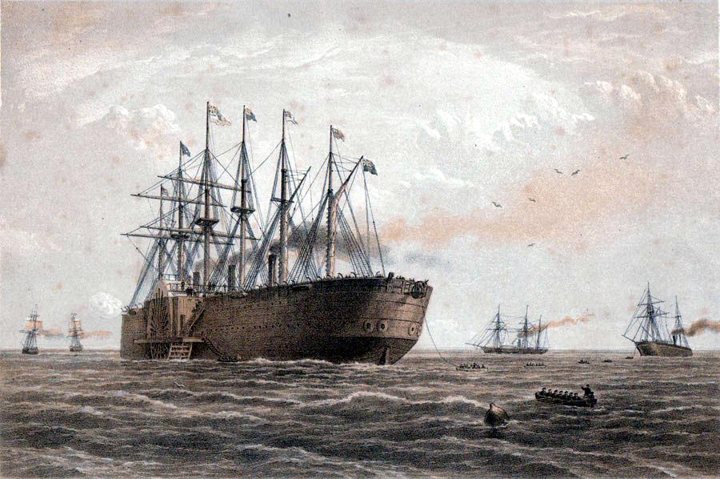

Fig. 2. The Great Eastern setting out from Ireland trailing the Cable. The pulses were broadened significantly on arrival and Kelvin explained this by treating the cable as a distributed R-C circuit. About six to eight words per minute could be sent.

The Heaviside Theory

The complete theory was developed by Oliver Heaviside in 1880. Heaviside is one of the unsung heroes of electrical engineering. He started as a telegrapher and never went to university but made an enormous contribution to the mathematics of electromagnetism. As well as the telegraphers’ equation he was responsible for putting Maxwell’s equations in a usable form, i.e. the vector notation we all use, so rescuing it from a morass of quaternions. Maxwell’s original equations involved nineteen partial differential equations in nineteen unknowns and emphasised the role of the electrostatic and vector potentials. Heaviside also developed the ‘D’ notation with D as a differential operator and gave his name to the conducting layer around the earth that allows long range radio to be possible. Heaviside’s circuit model of a cable is shown in fig. 3.

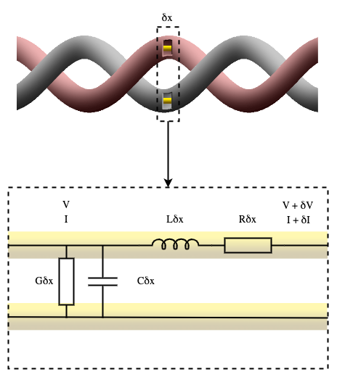

Fig. 3. Heaviside’s circuit model of a cable, which now appears in every undergraduate course of electrical engineering. The parameters per unit length are a resistance R, an inductance L, a capacitance C and a leakage conductance G.

Then
and
Hence
For a wave varying as

$k= \sqrt{LCω^{2}+jω\left(LG+RC\right)-RG}$ (4)

A special case is if , then;

In this case the velocity and attenuation are independent of frequency, which means a signal can be transmitted without any distortion. 1/k is the characteristic distance of the signal and each term has its own distance that needs to be compared with the length of the cable.

Cable Parameters

To continue this analysis, we need to look at the simple theory for the parameters L and C. For two wires of radius a and separated by a distance d immersed in any isotropic medium L = 2πμ ln(d/a) and C = 2πε/ln(d/a), where μ and ε are the permeability and permittivity of the medium. The expressions are the same for coaxial cables with a conductor radius a and outer sheath of radius d. Hence, in both cases, the velocity of a pulse is , the velocity of light in the medium. These are particular cases of a general result that holds true for any two-dimensional pair of conductors in which the currents and charges reside purely on the surfaces. It is because both the electrostatic potential for the electric field and the vector potential for the magnetic field (a scalar for 2D fields) obey Laplace’s equation, but with orthogonal boundary conditions. The equipotentials of an electrostatic problem correspond to the lines of force for a magnetic one. The capacitance and inductance of a cable are not independent parameters.

The second important conclusion is that the values of L and C do not vary much because the two-dimensional geometry means that the dimensions only appear as the logarithm of the ratio of the dimensions. Thus, for similar shapes they are independent of the absolute size, and the ratio can vary widely without much effect on the values. The relative permeability $\frac{μ}{μ_{0}}$ is usually unity, unless artificially raised, and the relative permittivity $\frac{ε}{ε_{0}}$ is between 1 and 3. Hence we will obtain a reasonable result within better than an order of magnitude for any cable by taking d/a as about 3 and $\frac{ε}{ε_{0}}$ as 2 so L= 0.2 μH/m and C=100 pF/m. (This applies equally to ADSL twisted wires.) The cross section determines the resistance of the copper conductors and is a crucial parameter. The larger the cross section, the lower is R, but the greater the weight that must be taken by steel wires wound round the outside of the cable. The value of R used was 2 mohm/m. The leakage conductance through the Gutta Percha insulator is more problematic. Data for polymers usually gives a range over several orders of magnitude. It is dependent on pressure and temperature, and also on time. It increased by a significant factor if a DC voltage was maintained for several minutes. This is because the polarisation of a polymer can have some very slow-moving dipoles so that the dielectric constant is frequency dependent. Also, electrons can move quite large distances before falling into local potential traps and stopping. This means that there is an ambiguity between what is classed as a polarisation and transport current since they are indistinguishable in their effects. It does not affect the Maxwell equation , since any current not treated as a changing P will appear in the J, so the total remains the same. However, for the purposes of G and C we will need different frequency dependent terms depending on the atomic mechanism. Measurements of resistivity gave values around 3x12¹² ohm m giving G = 10⁻¹⁰ S/m. Fortunately, we can usually assume G is small enough to be ignored, or at least use a very approximate value.

Transmission Lengths

Let us now look at the terms in equations and for the 3000 km long 1866 cable at a frequency of about 3 Hz or 7 words/min. The last term gives the decay length of a DC current, i.e. a leaky conductor, =1700 km so if we wait long enough the signal will transmit at about 1/6 of the applied voltage.

The first term is the wavelength of a pulse travelling with the velocity of light in a lossless transmission line. With this velocity a pulse will take about 0.01 seconds to arrive. The wavelength is 80,000 km, which is much longer than the cable so radiation effects are insignificant.

The most important term is therefore the middle term. Now RC/LG = 5500, so we can ignore the leakage conductance in this term, which also means the inductance is not important. The middle term with C and R is what Kelvin derived using distributed resistance and capacitance. For this term , which gives an exponential decay over a distance of 1300 km, which is about half the length of the cable. This is what determines the characteristics and since the solution is exponential, small changes in parameters will lead to large changes in the signal. It was fortuitous that this characteristic distance was comparable to the distance across the Atlantic. (Fortunately the Pacific, although wider, had enough islands to make a cable to Australia possible without any single submarine length longer than the Atlantic cable.) However, it is not the exponential decay that causes the problem, but the corresponding spreading of the signal in time, which is intrinsic to the diffusion equation.
The governing equation is therefore the diffusion equation with a diffusion coefficient of 1/(RC), which is how Kelvin treated it, i.e. as a distributed resistance and capacitance, before Heaviside derived the full equation. It can be seen that the most important design parameter in determining the attenuation is the resistance per metre, since there is not much we can do about the capacitance. The total series resistance was 6 kΩ with 3 MΩ in parallel.
For a pulse of unit height and width T the solution of the diffusion equation is;

(6)
Figure 4 shows the input and output voltage of a rectangular unit pulse lasting 0.1 seconds.

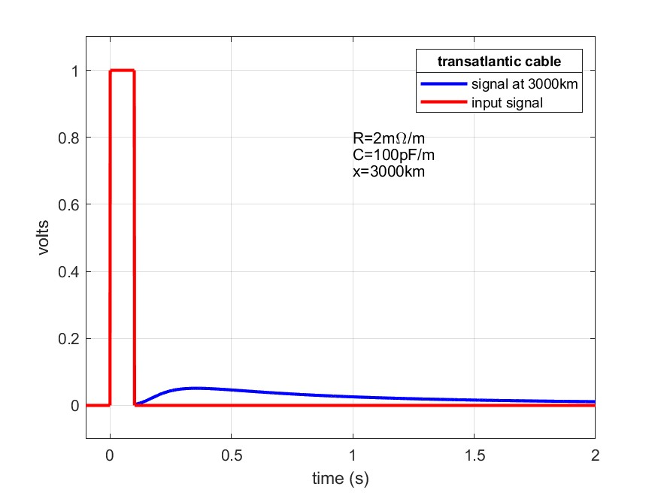

Fig. 4. The input and output voltage of a rectangular unit pulse lasting 0.1 seconds. A 1 volt input voltage for 0.1 seconds (red) and the result at the far end of the cable (blue).

The peak voltage is 0.05 volts for a 1 volt input and, since 50 volts could be used, the signal is easily detectable. The problem is that a short pulse is spread over about a second, which explains the 7 words a minute speed. Fig. 5 shows the sort of signal that could be read. The use of plus and minus for dot and dash shortened the time needed and avoided a continuous rise in voltage to the mean.

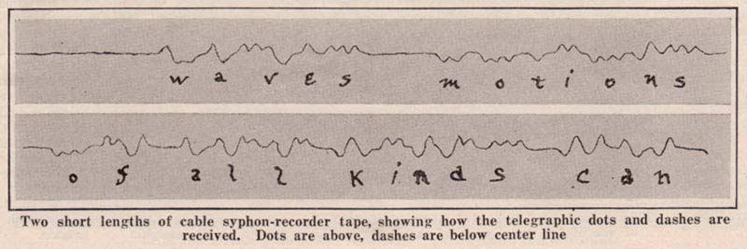

Fig. 5. A typical received signal (1922 Scientific American).

As pointed out above, the inductance and capacitance of the telephone lines we use for ADSL broadband internet communication are not very different from those of the Atlantic cable, but the resistance per unit length is 0.8 ohm/m so the attenuation is much higher. The only reason we can raise the frequency from 3 Hz to 6 MHz is that the cables are shorter. Figure 6 shows the length of ADSL cable that we might expect to be usable for frequencies from 1 to 6 MHz. In practice, considerably longer lengths can be used.

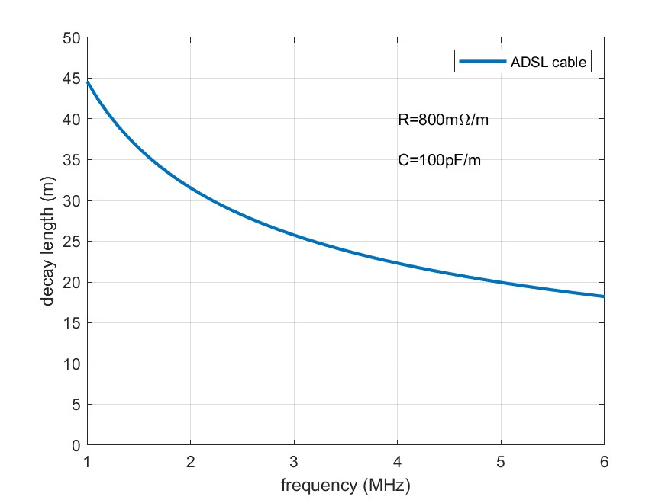

Fig. 6. The calculated decay length in metres for an ADSL line as a function of frequency, . The decay length is the distance at which the signal whill have dropped to 37% of its original amplitude.

Equation 3 shows that if LG = RC, the velocity is frequency independent, so only the attenuation depends on frequency and there is less distortion of a pulse. This was realised by Heaviside and explained why defective insulation in a telegraph line could improve the clarity of the signals. For the Atlantic cable increasing G to the required value would lead to a decay length √(L/CR²) =700 m, so this was not useful. However, an alternative is to increase L to get closer to the required condition. Unfortunately, the Post Office chief engineer Sir William Preece, did not take this seriously, and indeed did not think mathematics could contribute anything useful to telegraphy. It was the Americans who later filed the very profitable patents involved in loading telephone cables with inductance. Heaviside was rather bitter at this. Although his uncle was Sir Charles Wheatestone, Heaviside only had a small income from writing and a civil list pension.

Some further considerations

In this section we look at some issues that might seem to a physicist to be quite important but which are ignored in the general literature. These are the effect of the steel reinforcement, the effect of the sea water on capacitance and inductance, and a discussion of earthing currents.

The steel outer reinforcement
This was a set of steel wires round helically around the cable to provide the strength necessary to bear the weight of the more than three miles of cable that was being paid out. This was not just a dead weight since the ship was being tossed on the Atlantic waves, so there were large variable forces at play. One of the reasons the 1866 cable succeeded was the very much improved mechanical system of letting out the cable to reduce shocks caused by the waves.

A ferromagnetic sheath with a relative permeability of 100 would increase the inductance by a factor of about ten, and for touching cylindrical wires of about 3, but since the steel wires were surrounded by several millimetres of hemp, they were effectively isolated cylinders perpendicular to the applied field so demagnetising effects meant that they were not magnetised significantly. This also takes care of the problem that hysteresis loss in the steel might appear as an increase in effective resistance at the terminals, which is very difficult to calculate.

Malcolm (2) explains that the effect of the iron is to increase the inductance by 1 millihenry/nautical mile, which would imply that it was for a cable with the wires touching. His figure of 2-5 millihenrys per nautical mile implies a spread of the return current into the sea of about the skin depth of 100 m, as discussed below. It is difficult to find consistent figures for the inductance, partly as it is of little importance and partly because it would be difficult to measure. It is interesting to note that, although steel has a resistivity ten times that of copper, the cross section of steel was at least ten times that of the copper conductor, so that the resistance of the sheath was similar to that of the copper core. It might have been better to leave out the copper core and just keep the steel outside with a little more gutta percha to insulate it from the sea. As in overland telegraph wires, the decision between steel and copper is a close one, quite apart from the extra expense of copper compared to steel.

The effect of the surrounding ocean on the capacitance
Faraday rightly thought that the capacitance of long submarine cables would be a major problem and some authors have commented that the ocean surround will increase the capacitance, but this is not the case. The currents in the ocean do increase the inductance as discussed below, but we can show that there is no corresponding charge density in the ocean by using a very general result, which has wider implications. Suppose a charge ρ exists, then

Hence any charge density in a material decays exponentially with a time constant ε/σ. There is no harmonic solution so the only charge on the cable is at the sea-insulator interface. The steel wires essentially add a small, isolated capacitor in series and so do not have much effect. Any charge in the sea water will decay extremely rapidly so that the charge resides on the surface of the cable, as in air. The increase in capacitance compared with wires on poles is due to the dielectric constant of Gutta Percha (2.6) and the much smaller ratio of a to d. In a logarithm, this becomes about a factor of about three, so the capacitance of the cable is about ten times that of wires on land.

It is worth pointing out some general implications of equation (6). This means that any capacitor consisting of a simple dielectric between conducting plates will lose its charge over this time scale, whatever the geometry. This can be easily verified for the case of a parallel plate capacitor. The resistance and capacitance have the same dependence on the dimensions. The time constant, however, depends only on the material, not on the dimensions. The best material is PTFE with a time constant of 48 hours, but for most insulators it is much less. It should also be noted that the resistivity of an insulating dielectric is a rather indeterminate quantity due to the slow relaxation of some of the polarisation.

The earth return currents and inductance
Earthing is something that electrical engineers use all the time, but the physics is not immediately obvious. Earthing is often used rather vaguely to imply that anything connected to earth is uncharged and that we can pass arbitrary currents into the earth, since it is very big (the capacity of the earth is about 1 Farad). However, it is worth clarifying these ideas with some specific examples.

It is unlikely that the earth has zero charge (this might be detectable through its effect on satellites), although we can take the potential of the earth as zero without loss of generality since only potential differences have meaning in the flow of electrical current.

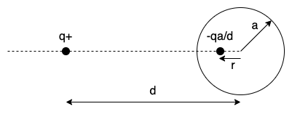

Fig. 7. The electrostatics of a charge and a conducting sphere.

Take first an earthed conducting sphere of radius a, a distance d from a charge q (fig. 7.). It is readily shown that if we put a charge –qa/d a distance r from the centre where rd=a² then we obtain zero potential on the surface of the sphere. If, instead of zero potential, we have a neutral sphere, we need to add a charge qa/d at the centre, since this maintains the surface at an equipotential but gives zero net charge. If the earth is not at infinity we can add images in the earth plane, but this is an unnecessary complication.

Now suppose we start with an isolated charge and bring up an insulated sphere to a distance d. The sphere will be at a potential due to the centre charge of q/4πε_{o}d since the other two charges cancel. This is the potential at the position of the centre of the sphere before its arrival. We obtain the situation in fig. 7 if we now connect the sphere to earth. To reach this situation a charge has flowed from earth to the sphere. This is the basis of the Victorian device called an electrophorus. If, having earthed the sphere we then remove it, it will retain its charge and can produce sparks. The process can be repeated indefinitely providing a continuous source of electrostatically charged spheres from the single charge q, since it is only earthing the sphere that causes it to become charged.

More relevant to the cable is the resistance offered to a current going into an earthed conductor.

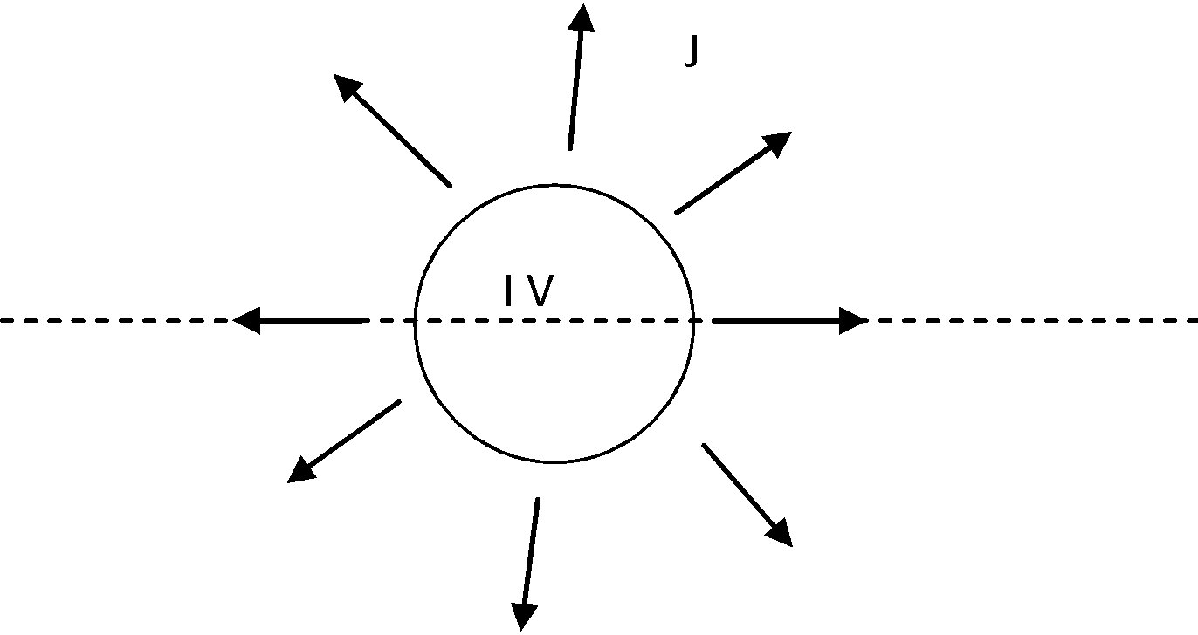

Fig. 8. Current flowing from a sphere in an infinite conducting medium.

Fig. 8. shows a sphere of radius a in an infinite conducting medium with a current I transmitting at a voltage V. Since current is conserved, the current density at a distance r is J = I/4πr² . If the resistivity of the medium is ρ, then E = ρJ = ρI/ 4πr². The voltage V is the integral of E, V = ρI/ 4πa so the resistance to earth is ρ/ 4πa. A more realistic geometry is the half plane shown by the dotted line (a hemisphere at the surface), which doubles the resistance. A typical clay soil might have a resistivity of 20 ohm m so a 1 m radius sphere, (or flat plate) would have an earth resistance of about 3 ohms, very much less than the cable resistance, but, as discussed below, the situation is not quite so simple. In sea water it would be a factor 100 lower.

An example of this geometry is when lightning hits the ground. The current spreads out, falling in density in proportion to the radius, creating a significant electric field. This explains why it is not uncommon to find dead animals laid out radially around a lightning strike. A strike of 30000 A would give a voltage of 2 kV across a cow 10 metres away if the soil has a resistivity of 20 ohm m.

Humans with two legs are less susceptible as long as they keep their feet together.

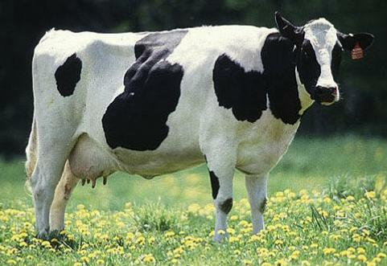 | 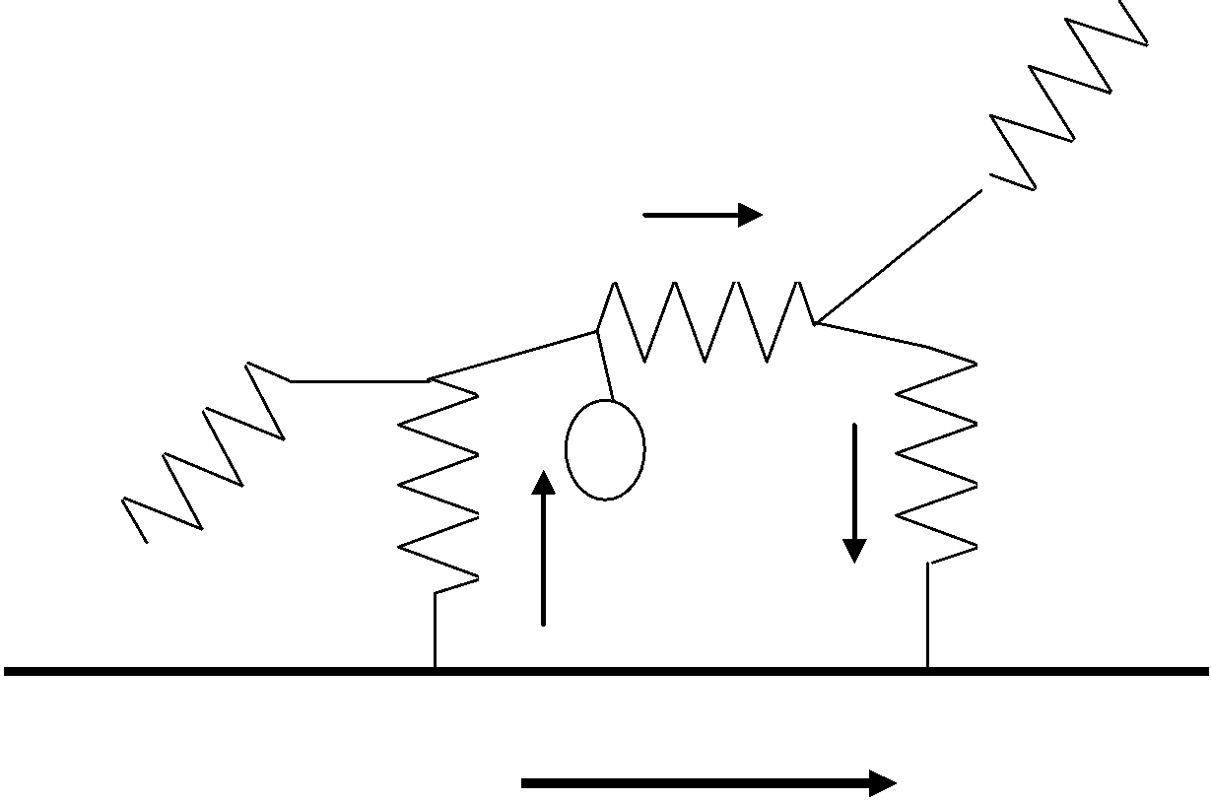 | 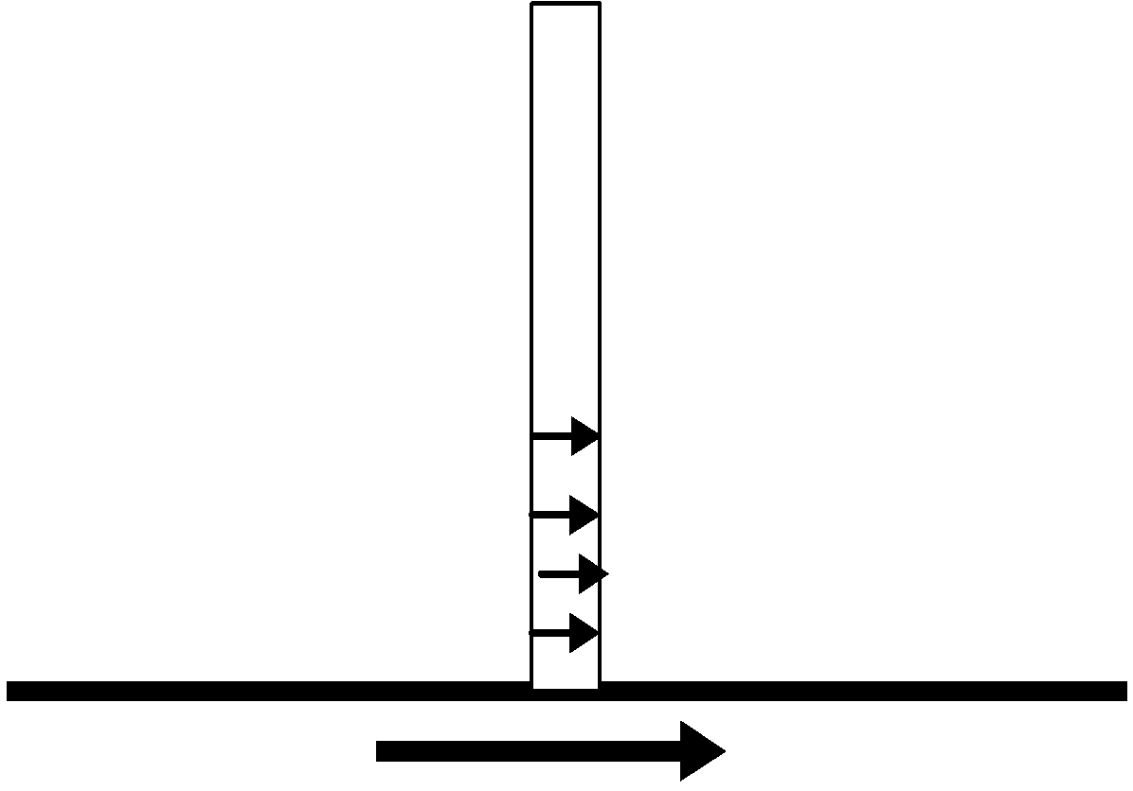
(a) | (b) | (c)

Fig. 9. (a) A cow, (b) a cow equivalent circuit and (c) a human with legs together.

The electric field, and hence current density decays rapidly as d/y, where d is the leg thickness and y the distance up the leg, as well as there being a much smaller potential difference. When people are struck, the current pulse is very short and, if they are lucky, is confined to their surface although they may be left naked when their clothes burn off. This is an example of the ‘skin effect’ which is what we need to explain the return current in the Atlantic cable.

A DC circuit between two terminals with the depth of the current comparable to the distance between terminals, i.e. several thousand kilometres for the cable. The exact distribution can easily be obtained from the inverse square law between two charges as shown in fig. 8. This implies that the changes in magnetic field associated with the current must penetrate to this depth, which takes a long time, and why we need to consider the skin effect.

The standard derivation is;
This is the diffusion equation with a diffusion coefficient D = 1/μ_{o}σ. We can use the general expression for the time to penetrate a distance x for any diffusion equation t = x²/D, which is about 6 days for 3000 km in wet soil. Hence, although we do not normally worry about the skin effect at 3 Hz, if we are dealing with 3000 km systems it is essential.

At this frequency the skin depth in sea water is about 100 m so that the current returns in a cylinder around the cable of about 100 m radius and this has a resistance of 22 ohms. Hence the earth return has a very low resistance compared with that of the cable.

However, the second effect is that the magnetic field is no longer confined to the outer surface of the cable as in a coaxial cable. It is spread out over 100 metres. This increases the inductance by a factor of about eight over the value expected from the capacitance. However, as we have seen, the inductance is not an important parameter.

The situation is changed for telephone cables, which need frequencies of many kilohertz. As the frequency increases the current is compressed towards the cable and the resistance increases in proportion to the frequency, to several kilohms. More current is carried in the steel and telephone cables used a copper outside conductor to carry the return current and reduce the total resistance. They also need repeaters at frequent intervals and were a much more complicated proposition.

Costs

Laying the cable was a very expensive proposition and the cost of sending a message was about $5 a word, which was a lot of money in 1866. The U.S. State department’s first use was a telegram demanding that Napoleon III remove his troops from Mexico. It cost $20,000 but this was because the complex code they used meant that the message contained 3,500 words. The main economic attraction of the cable seems to be that the fast information on the availability of materials around the world meant that traders could make much more efficient use of their resources in buying and selling goods and did not need stock such large reserves of materials in case of shortages. The cable must have made a profit as several more cables were laid over the following twenty years.

References

1) The Atlantic Cable, Bern Dibner, Burndy Library Norwalk Conn. 1959.
2) The Theory of the Submarine Telegraph and Telephone Cable, H. W. Malcolm, Benn Brothers, London, 1917.

